

EvoScan Power Graphing Tutorial

Contents

EvoScan Power Graphing Tutorial 1
1 What is Power Graphing? 2
2 Opening Power Graph-screen 3
3 Parts of Power Graph –screen 4
3.1 Chart Template Selection 4
3.2 Log Tabs 5
3.3 Power Tab 6
3.4 Zoom Out Button 10
3.5 Chart Series Legend 10
3.6 Chart Area 10
3.7 Chart Scroll Bars + Info 12
3.8 Load Logs Buttons 12
3.9 MapTracer Button 12
3.10 Cross Chart Button 12
3.11 Smoothing Selection 14
3.12 Synchronise Bars Selection 15

1 What is Power Graphing?

EvoScan Power Graphing is a tool for drawing graphs on selected log file items and calculated power and torque.

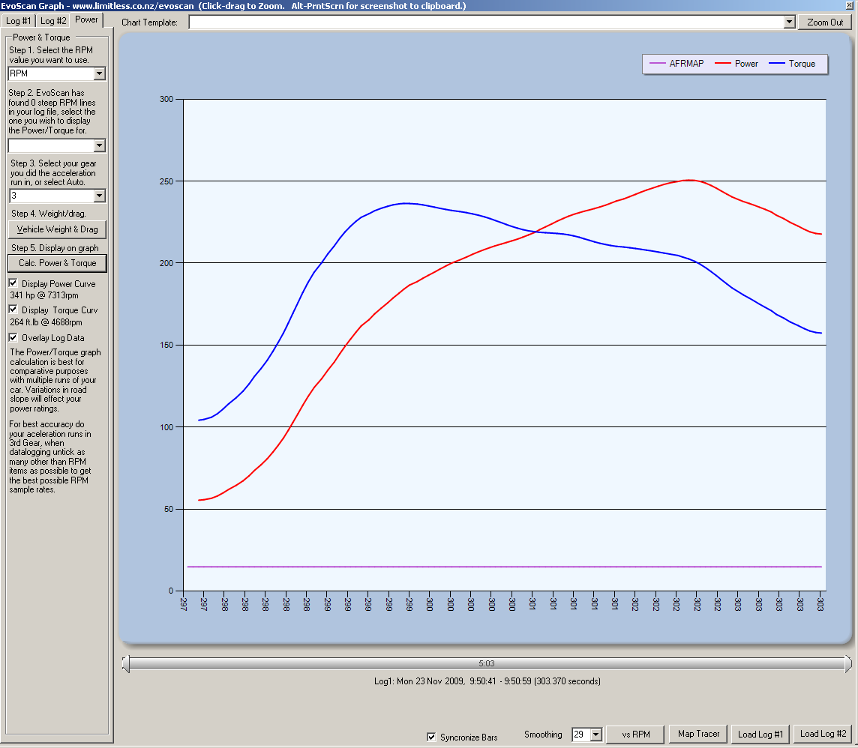
Img1: Power Graph -screen

2 Opening Power Graph-screen

On EvoScan main screen open Graphs & MapTracer menu and choose Analyse .csv Log File – Graphing log Data, Power and Torque. After that a file browser pops up for you to choose the log file you wish to analyse. If you have your log file opened in another application, you should close it before opening it with EvoScan.
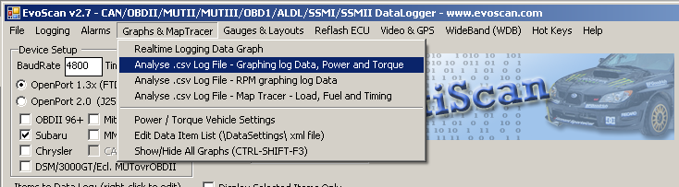
Img2: Opening Power Graph-screen on EvoScan main screen

3 Parts of Power Graph –screen
1 Chart Template Selection
4 Zoom Out Button
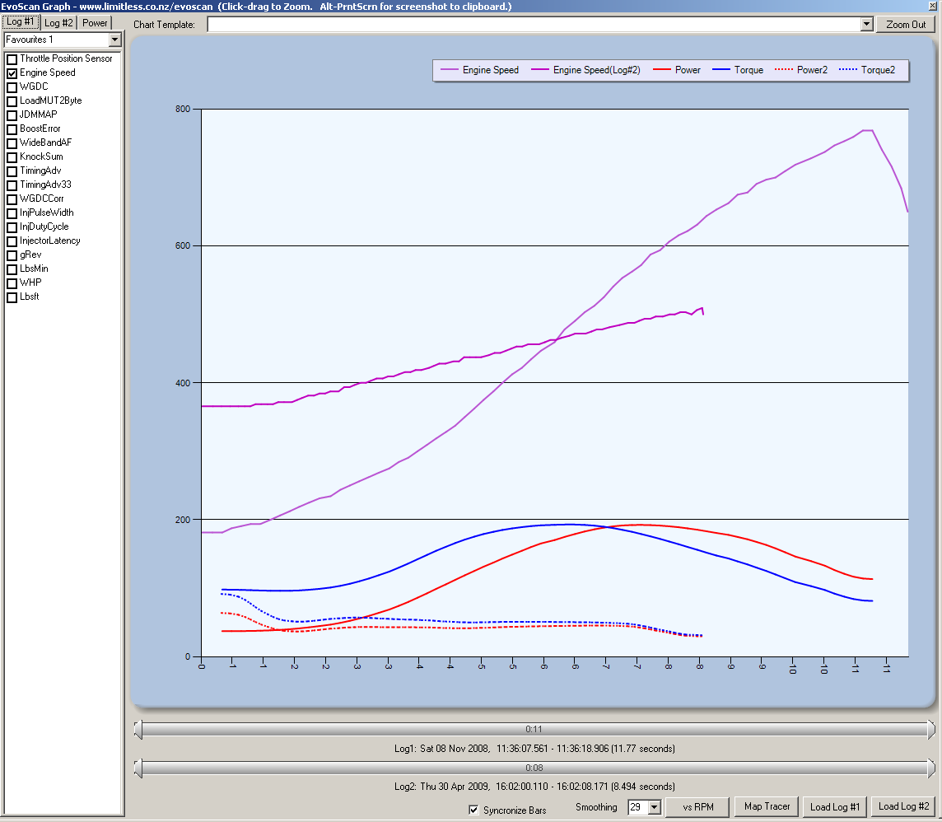
5 Chart Series Legend
2 Logs Tabs
3 Power Tab
6 Chart Area

7 Chart Scroll Bars + Info

8 Load Logs Buttons
12 Synchronise Bars Selection
11 Smoothing Selection
10 Cross Chart Button
9 Map Tracer Button

Img3.1: Different parts of Power Graph -screen

3.1 Chart Template Selection
Chart template selection determines the look of the chart (background and line colours, legend etc). Available templates are: Berry, Chocolate, Default Palette, Dundas, EarthTones, Excel, Fire, GrayScale, Light, Pastel and SeaGreen. You can also create your own templates and save them in EvoScan\ChartTemplates-folder and they will be listed in the combo box as well.

3.2 Log Tabs
Two separate log files can be loaded on Power Graphing screen. Items to be shown from each log file can be chosen on their respective tabs as well as the favourite settings.
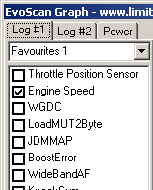
1 Logs Tabs
2 Favourites Selection

3 Log Item Selection

Img3.2: Log Tabs

3.2.1 Favourites Selection
You can save your favourite item selections and use them by changing the selection on the Favourites-combo box. You can save separate favourites for each log files. Favourites are saved automatically when Power Graph -screen is closed. Favourites are the same for Cross Chart, Power Graph and MapTracer –screens.

3.2.2 Log Item Selection
On the Log Item Selection list you can see all the items found in your log file. Select the ones you want to view on the Graph.

3.3 Power Tab
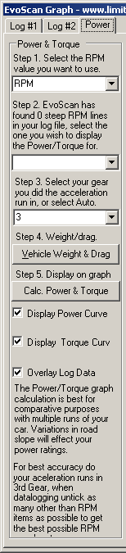

1 RPM Selection

2 RPM Run Selection

3 Gear Selection

4 Vehicle Weight & Drag Button

5 Calc. Power & Torque

6 Display Power Curve

7 Display Torque Curve

8 Overlay Log Data

Img3.3.1: Power Tab

3.3.1 RPM Selection
RPM combo box lists all RPM items found in the log file. The selection determines which RPM item will be used in power and torque calculations.

3.3.2 RPM Run Selection
RPM Run combo box lists all the RPM runs found in the log file. The selection determines which RPM run will be used in power and torque calculations.

3.3.3 Gear Selection
Gear Selection combo box lists gears (1-6) and Auto options. You should select the gear you did the acceleration run in or select Auto.

3.3.4 Vehicle Weight & Drag –Button
Vehicle Weight & Drag –button opens up the Power / Torque Settings screen.
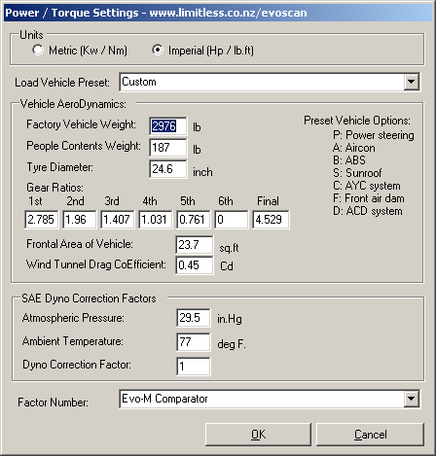
1 Units Selection

2 Vehicle Preset Selection
4 Contents Weight
6 Gear Ratios
8 Drag
10 Temperature
3 Vehicle Weight
4 Contents Weight
4 Contents Weight
6 Gear Ratios
8 Drag
10 Temperature
5 Tyre Diameter

6 Gear Ratios
4 Contents Weight
6 Gear Ratios
8 Drag
10 Temperature
7 Frontal Area
8 Drag CoEfficient
4 Contents Weight
6 Gear Ratios
8 Drag
10 Temperature
9 Atmospheric Pressure
10 Ambient Temperature
4 Contents Weight
6 Gear Ratios
8 Drag
10 Temperature

11 Dyno Correction Factor
12 Factor Number

Img3.3.2: Power / Torque Settings -screen

3.3.4.1 Units Selection
You can choose your units to be metric or imperial. If you change the selection, all your settings will be converted to the new units. Power and torque will also be in the unit chosen here.
 | Metric | Imperial
Power | kW | HP
Torque | Nm | Ft. lb
Weight | Kg | Lb
Tyre diameter | Cm | Inch
Frontal area | Sq.m | Sq.ft
Pressure | kPa | In.Hg
Temperature | Deg c. | Deg f.
Table 1. Units used depending on Metric/Imperial selection

3.3.4.2 Vehicle Preset Selection
EvoScan has preset settings for the following vehicles. All changes will be saved on Custom-selection and preset settings will remain unchanged. Preset settings have default values to each of the settings shown on settings screen:
- Evo4 RS (P)
- Evo4 RS (P, A)
- Evo4 RS (P, C)
- Evo4 RS (P, A, C)
- Evo4 GSR (P, A, B, C)
- Evo4 GSR (P, A, B, C, S)
- Evo5 RS (P)
- Evo5 RS (P, A)
- Evo5 RS (P, B)
- Evo5 RS (P, A, B)
- Evo5 RS (P, F)
- Evo5 RS (P, B, F)
- Evo5 RS (P, A, B, F)
- Evo5 RS (P, C)
- Evo5 RS (P, A, C)
- Evo5 RS (P, B, C)
- Evo5 RS (P, C, F)
- Evo5 RS (P, A, C, F)
- Evo5 RS (P, B, C, F)
- Evo5 RS (P, A, B, C, F)
- Evo5 GSR (P, A, B, C, F)
- Evo5 GSR (P, A, B, C, F, S)
- Evo6 RS (P)
- Evo6 RS (P, A)
- Evo6 RS (P, C)
- Evo6 RS (P, B)
- Evo6 RS (P, A, B)
- Evo6 RS (P, A, C)
- Evo6 RS (P, B, C)
- Evo6 RS (P, A, B, C)
- Evo6 GSR (P, A, B, C)
- Evo6 GSR (P, A, B, C, S)
- Evo7 RS
- Evo7 GSR
- Evo8 RS (A)
- Evo8 RS (B, D)
- Evo8 RS (A, B, D)
- Evo8 GSR (A, B, D)
- Evo8 GSR (B, D)
- Evo9 RS 5Speed (A)
- Evo9 RS 5Speed (B, D)
- Evo9 RS 5Speed (A, B, D)
- Evo9 RS 6Speed (A, B, D)
- Evo9 RS 6Speed (B, D)
- Evo9 GSR 6Speed (A, B, D)
- Evo9 GSR 6Speed (B, D)
- Evo10 GSR 5Speed MT
- Evo10 GSR 6Speed TC-SST

3.3.4.3 Vehicle Weight
Enter your vehicle weight without any passengers. If your vehicle is listed in the Preset combo box, you don’t have to change this. If your vehicle is not listed look this value up in the technical manual for your vehicle.

3.3.4.4 Contents Weight
Additional contents weight, such as people, toolboxes, anything non factory. Default value for all vehicles is 85 kg (187 lb).

3.3.4.5 Tyre Diameter
Tyre Diameter from outside to outside. Default value for all vehicles is 62.4 cm (24.6 inch).

3.3.4.6 Gear Ratios
Gear ratio is the relationship between the numbers of teeth on two gears.

3.3.4.7 Frontal Area
Frontal area is the total surface area of the front of a car that is exposed to airflow. Default value for all vehicles is 2.2 sq.m (23.7 sq.ft).

3.3.4.8 Drag CoEfficient
Drag CoEfficient is the value representing the magnitude of the aerodynamic drag that works against the forward movement of the vehicle. If you don't know your Drag CoEfficient, start with 0.95. Default value for all vehicles is 0.45 Cd.

3.3.4.9 Atmospheric Pressure
Atmospheric pressure is the pressure exerted by the atmosphere. Default value for all vehicles is 99.9 kPa (29.5 in.Hg).

3.3.4.10 Ambient Temperature
Ambient temperature is the temperature of the space (air) around the motor. Most motors are designed to operate in an ambient not to exceed 40C (104F). Default value for all vehicles is 52 deg C. (77 deg F.).

3.3.4.11 Dyno Correction Factor
Dyno correction factor is the mathematical reciprocal of the relative power value. It’s used to standardize the power and torque readings, so that the effects of the ambient temperature and atmospheric pressure are removed from the readings. By using the dyno correction factor, power and torque readings can be directly compared to the readings taken on some other day, or even taken at some other altitude. Default value for all vehicles is 1.0.

3.3.4.12 Factor Number
Available Factor numbers are: Evo-M Comparator, Dynojet (Average), Mustang (Average), Buschur Racing Mustang, E.S.P. Mustang, GST Motorsports Mustang and User Correction 1. Default value for all vehicles is Evo-M Comparator.

3.3.5 Calc. Power & Torque –Button
This button calculates the power and torque based on the settings.

3.3.6 Display Power Curve
If this option is chosen, power curve will be shown on the graph if it has been calculated. Power for Log#1 will be shown on solid red line and if Log#2 is loaded it will be shown in dotted red line.

3.3.7 Display Torque Curve
If this option is chosen, torque curve will be shown on the graph if it has been calculated. Torque for Log#1 will be shown on solid blue line and if Log#2 is loaded it will be shown in dotted blue line.

3.3.8 Overlay Log Data
If this option is chosen, the log data chosen on logs tabs will be shown on the graph.

3.4 Zoom Out Button
You can zoom in the graph both horizontally and vertically. To get back to original size you can use Zoom Out button. Each press of Zoom Out button resets zooming by one, so if you have zoomed in more than once, you will have to press the button several times to get back to the original size.

3.5 Chart Series Legend
This will show which colours on the graph are used for each series on the graph. Series from Log#2 are indicated by text “(Log#2)” after the data item name. Power and Torque for Log#2 are dotted lines on the graph and all the others are solid.

3.6 Chart Area
This is where the graph is drawn. X axis is seconds and Y axis depends on the item selection. When placing the mouse over a line on the graph a tooltip pops up to show more detailed info on graph. In the tooltip you can see the values on that specific point for each selected data item and also power and torque if they are selected.
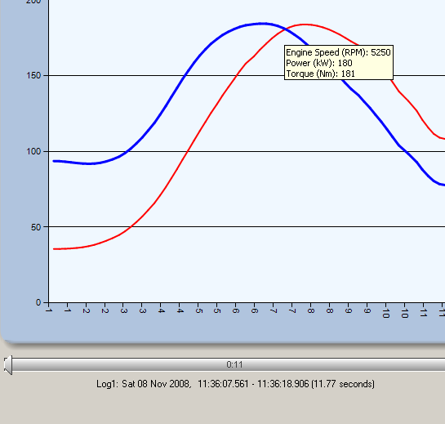
Img3.4.1: Chart Area Tooltip

3.6.1 Chart Area Context Menu
Chart area has a context menu. When you right-click on the chart area you get three menu items; Zoom Out, Enable Horizontal Zooming and Calculate Power/Torque.
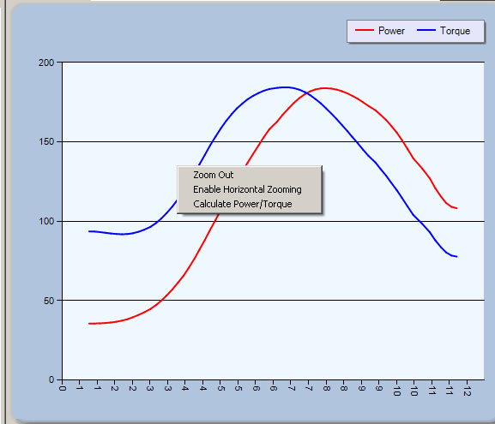
Img3.4.2: Chart Area Context Menu

3.6.1.1 Zoom Out
Zoom Out works exactly the same as Zoom Out button i.e. resets the zooming by one on the chart area.

3.6.1.2 Enable Horizontal Zooming
Enable Horizontal Zooming lets you also zoom in horizontally if selected. To zoom in horizontally simply hold down left mouse button on the chart area and drag to mark the area you want to zoom into.
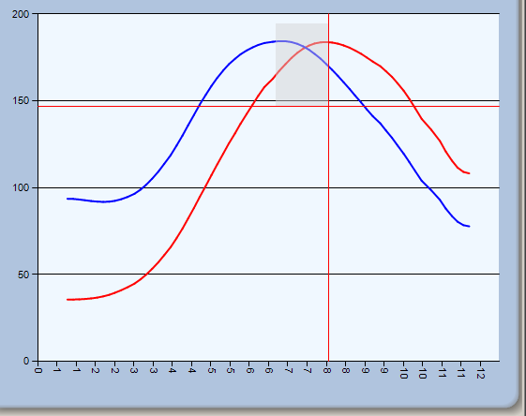
Img3.4.3: Chart Area zooming with horizontal zooming enabled

3.6.1.3 Calculate Power/Torque
Calculate Power/Torque works the same as Calc. Power & Torque button. It calculates the power and torque based on the Power/Torque Settings.

3.7 Chart Scroll Bars + Info
You can zoom in the chart by using the scroll bar and once zoomed in, you can use the scroll bar to scroll the chart. Scroll bars on the chart area will also be visible when chart is zoomed in. If Log#2 is loaded, a separate scroll bar is visible for it. If Synchronise Bars –option is selected, the scroll bars will be synchronised, otherwise you will be able to scroll each log separately.
Info below the scroll bars tells the date, time and duration of the data log.

3.8 Load Logs Buttons
You can load two separate logs onto the Power Graph –screen. Power and Torque will be calculated for both logs and you can choose the data items you want from each log.

3.9 MapTracer Button
This button opens up MapTracer-screen and automatically loads logs loaded in Power Graph –screen onto the MapTracer screen.

3.10 Cross Chart Button
This button opens up Cross Chart –screen. Cross Chart –screen can also be opened from the main screen Graph & MapTracer – Analyse .csv Log File – RPM graphing log Data.
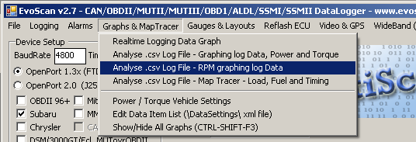
Img3.10.1: Opening Cross Chart –screen from Main screen

1 Template Selection
2 Limit Values Selection
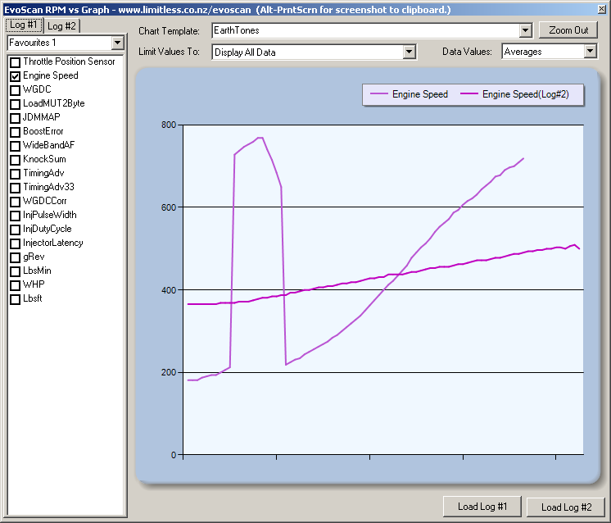
6 Zoom Out Button
5 Item Selection
3 Logs Tabs
7 Values Selection
8 Chart Series Legend
9 Chart Area
10 Load Logs Buttons

4 Favourites Selection
7 Values Selection

8 Chart Series Legend

9 Chart Area

10 Load Logs Buttons

Img3.10.2: Cross Chart –screen

3.10.1 Template Selection
Chart template selection determines the look of the chart (background and line colours, legend etc). Available templates are: Berry, Chocolate, Default Palette, Dundas, EarthTones, Excel, Fire, GrayScale, Light, Pastel and SeaGreen. You can also create your own templates and save them in EvoScan\ChartTemplates-folder and they will be listed in the combo box as well.

3.10.2 Limit Values Selection
Limit Values Combo box has two default options: Display All Data and Current Selected Graph Range. In addition to these options, the combo box lists all found RPM runs.

3.10.3 Logs Tabs
Two separate log files can be loaded on Cross Chart screen. Items to show from each log file can be chosen on their respective tabs.

3.10.4 Favourites Selection
You can save your favourite item selections and use them by changing the selection on the Favourites-combo box. You can save separate favourites for each log files. Favourites are the same for Cross Chart, Power Graph and MapTracer –screens.

3.10.5 Item Selection
On the Log Item Selection list you can see all the items found in your log file. Select the ones you want to view on the Graph.

3.10.6 Zoom Out Button
You can zoom in the graph both horizontally and vertically. To get back to original size you can use Zoom Out button.

3.10.7 Values Selection
Values Selection has three options; Averages, Minimums and Maximums.

3.10.8 Chart Series Legend
This will show which colours on the graph are used for each series on the graph. Series from Log#2 are indicated by text “(Log#2)” after the data item name. Power and Torque for Log#2 are dotted lines on the graph and all the others are solid.

3.10.9 Chart Area
This is where the graph is drawn. X axis is RPM and Y axis depends on item selection. When placing the mouse over a line on the graph a tooltip pops up to show more detailed info on graph. In the tooltip you can see the values on that specific point for each selected data item and also power and torque if they are selected.

3.10.10 Load Logs Buttons
You can load two separate logs onto the Cross Chart –screen. The logs loaded on the Power Graph screen are automatically loaded on the Cross Chart –screen.

3.11 Smoothing Selection
This selection helps smooth out the Graph. A value of '1' applies no smoothing to the graph. You want to start at the lowest value and slowly increase the smoothing until the irregular bumps begin to smooth out. Applying too much smoothing will cause inaccurate results so only apply enough smoothing to take the shape of the curve free-flowing without drastic changes. The maximum smoothing value is 29, though most logs will end up between 4 and 20 depending on the resolution of the data file. The less data items you record in your log, the higher (and more accurate) your results will be.

3.12 Synchronise Bars Selection
If Synchronise Bars option is selected, both log files will be scrolled simultaneously, otherwise they will be scrolled separately.

